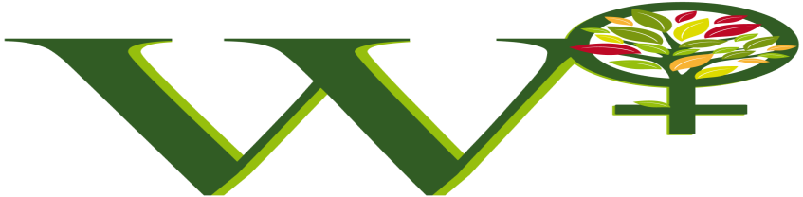

W+ Project Idea Note (PIN) Template

This template is for the development of W+ projects. The key elements of the W+ PIN are:

- W+ Standard Project Identification
- Applicant Details
- Location of W+ Project
- General Information on domains selected and associated activities
- Project Implementation team and W+ measurement team

Instructions for completing the PIN:
TITLE PAGE: All items in the box on the title page must be completed. The box (on following page, below) must appear on the title page of the final document. Project descriptions may also feature the project title and preparers’ name and logo more prominently on the title page, using the format below.
PROJECT DESCRIPTION: Instructions for completing the project idea note template are given under the section headings in this template. This template must be completed in accordance with the W+ Standard, Program Guide, and any other relevant guidance documents, and the preparer will need to refer to these program documents to complete the template. Note that the instructions in this template are intended to serve as a guide and do not necessarily represent an exhaustive list of the information the preparer should provide under each section of the template.
All sections must be completed. Where a section is not applicable, “not applicable” must be stated under the section and the section must not be deleted from the final document.
Use a sans serif font (such as Arial or Calibri), 12pt, black, regular (non-italic) font.

All instructions, including this introductory text, should be deleted from the final document.

W+ PROJECT IDEA NOTE (PIN)

Country:

Title of Project:

1. Project Identification

Title of Project
Project Start Date
Project End Date
Bref Summary of Women’s Empowerment Activity(ies):
W+ Domains applied:
W+ Labeling: | If seeking W+ labeling, describe associated standard (e.g. CDM, VCS), applicable domains and timeframes
Date of submission:

2. Applicant Details

Applicant
Name
Type of organisation | ⃝ Government agency ____________________________  ⃝ Municipality __________________________________  ⃝ Private company ________________________________  ⃝ NGO________________________________________  ⃝ Other: ______________________________________
Name of contact person
Address
Phone
E-mail
URL

Co-Applicant(s) (if applicable) | [if more than one, please copy this part of the table]
Name of co-applicant(s)
Type of organisation(s) | ⃝ Government agency _____________________________  ⃝ Municipality ___________________________________  ⃝ Private company________________________________  ⃝ NGO _________________________________________  ⃝ Other: _____________________________________
Name of contact person(s)
Address
Phone
E-mail
URL

W+ Project advisor(s) (if different than applicant)
Name
Type of organisation | ⃝ Government agency ____________________________  ⃝ Municipality __________________________________  ⃝ Private company ______________________________  ⃝ NGO __________________________ ______________  ⃝ Other: ______________________________________
Name of contact person(s)
Address
Phone
E-mail
URL

3. Location oF project

Location of Project
Country
Region/State/Province etc.
City/Town/Community etc.
Brief narrative description of the project location
GPS coordinates of the project’s activity(ies)

4. WOMEN’S EMPOWERMENT ACTIVITIES

General Information
Provide a brief description of the rationale for applying the W+ Standard and selected domains
(reason or opportunity)

Describe number of women benefiting from activities associated with the project.

If the Project intends to generate W+ Units and seek W+ labelling of carbon credits, explain how the applicant will differentiate W+ Units from W+ labelling to ensure there is no double-monetizing of units.

W+ domains applied and associated activity(ies)
For each W+ domain applied, describe associated activities and expected benefits

Specify start date and end date (if applicable) for each activity

Additional information

Summarize potential concerns and mitigating measures, and how they have been identified

Linkages to other types of projects
Is this project registered under any other standard or certification scheme? | - CDM  - Gold Standard  - Voluntary Carbon Standard  - Social Carbon  - Plan Vivo  - Fair Trade  - Forest Stewardship Council  - Organic Certification  - SA 8000  - GlobalGAP  - Other (please specify)
Crediting period under the other Standard or certification scheme

Name of certification body

5. PROJECT IMPLEMENTATION & W+ MEASUREMENT TEAM

Project implementation team
Describe the organisations and persons that carry the responsibilities related to:
- planning and implementing activities
- monitoring and evaluation
- gender/women’s empowerment
The essential qualifications and experiences should be briefly presented.

W+ measurement team
Qualifications related to:
- Monitoring and evaluation
- Gender/women’s empowerment
The essential qualifications and experiences should be briefly presented.

Schedule
Current status of women’s empowerment project activities (if applicable) | ☐ planning stage  ☐ operating less than 2 years  ☐ operating more than 2 years
Status of financing women’s empowerment activities
Has permission been obtained from relevant authorities, if needed? | ☐ yes  ☐ no  ☐ other (please specify):

PIN Template Revision History (box to be removed from final document)
# | Date | Description
1 | 2015 (version 1.0) | Original
2 | May, 2017 (version 1.1) | Edits to nomenclature for consistency. Removal of redundant information requests. Addition of time-frames and specificity regarding multiple domains and prevention of double-counting.
3 | May 2019 (version 1.2) | Addition of overall start and end dates of project, number of women per activities, expected benefits instead of indicators (indicators would be required at the PDD level)
4

